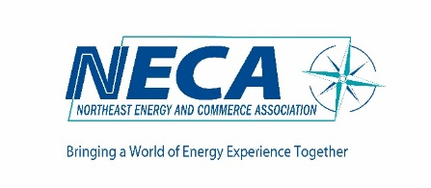

2026 Sponsor Application
Option 1:
Sponsorship Level: | Minimums |  | Select one
Platinum | $10,500 |  | [ ]
Gold | $8,000 |  | [ ]
Silver | $5,500 |  | [ ]
Option 1: Allocation of Year-Long Commitment Option 2: Pay as You Go
Event |  | Corporate Premier Corporate Premier
Spring Conference (6/4) |  | Cost |  |  |  |  | Cost
Annual Spring Sponsor | [ ] | $1,800 |  | [ ] $3,600 [ ] $1,900 [ ] $3,800 |  |  | [ ] $3,500 [ ] $1550 [ ] $3,550
Annual Spring Exhibit* | [ ] | $1,500 |  | [ ] $1,600
101s / Webinars
Webinar of Choice** | [ ] | $500 |  | [ ] $500
Other In Person Events
Renewables Sponsor (3/18) | [ ] | $800 |  | [ ] $1,600 [ ] $850 [ ] $1,700 |  |  |  |  |  |  |  |  | $1,500
Renewables Exhibit* | [ ] | $825 |  | [ ] $875
Fuels (Fall) | [ ] | $800 |  | [ ] $1,600 [ ] $850 [ ] $1,700
Power Markets (1/29) | [ ] | $800 |  | [ ] $1,600 [ ] $850 [ ] $1,700
Environmental (4/16) | [ ] | $700 |  | [ ] $1,400 [ ] $750 [ ] $1,500
Retail Markets Event | [ ] | $700 |  | [ ] $1,400 [ ] $750 [ ] $1,500
Innovation Forum or Holiday Event (Fall) | [ ] | $500 |  | [ ] $1,000 [ ] $550 [ ] $1,100
Board Meeting |  |  |  | [ ] $275
* Further discount offered if sponsoring and exhibiting the same event
** Sponsors can develop the topic, speak, etc.
Please invoice me for $_________________________________________________________________________

Company Name (as you wish to be listed): _________________________________________________________

Contact Person, Email and Phone: ________________________________________________________________

Please return to marla@necanews.org

